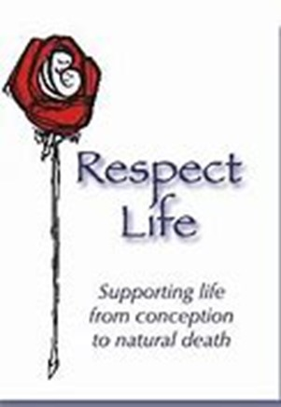
Respect Life Ministry
St Anthony of Padua Church

Mission Statement
The mission of St. Anthony of Padua Respect Life Ministry is to protect and defend the most fundamental right of humankind, the right to life of every human being from the beginning of life to natural death.

America’s first document as a new nation, The Declaration of Independence, states that we are all “created equal” and endowed by our Creator “with certain unalienable Rights, that among these are Life…” Our Founding Fathers emphasized the preeminence of the right to “Life” by citing it first among the unalienable rights this nation was established to secure.

We carry out our lifesaving mission by promoting respect for the worth and dignity of every individual human being, born or unborn, including unborn children from their beginning; those newly born; persons with disabilities; older people; and other vulnerable people, especially those who cannot defend themselves.

Membership and Meetings
We meet on the third Thursday of each month in the church chapel to pray the prolife rosary followed by a short business planning meeting in the Community room. All are welcome to come and participate in the rosary, and/or the meeting.
History and contact info
The ministry has been active in the parish for the last 12 years. We welcome ALL parishioners to join the ministry. We really need more members so please consider joining our ministry. Contact Tom McGeachen 609-448-8399, email: tjmcgeachnj@hotmail.com
What has been done in the past
- Fund raising dinner, Baby Bottle Raiser , and Baby Showers to support local Respect Life organizations such as BirthRight of Freehold, Options for Women Trenton, Good Counsel Homes for crisis pregnancy, Legacy of Life, Project Rachel Trenton Diocese, Choice One, New Jersey Right to Life, and St. Peter Hospital Foundation
- Over $21,000 (checks and items) has been donated in the last 12 years to these local respect life organizations.
- Support annual Right to Life (RTL) March in Washington DC every January
- Support annual RTL rally in Trenton NJ
- Prolife signs on church property
- Support NJRTL organization statewide raffle

Planned Events 2022
- Spring and Fall Baby Showers to donate items to local crisis pregnancy centers
- Prolife Stations of Cross Lent 2022
- Spiritual Adoption in progress and ending in Fall of 2022
- Continue to support New Jersey Right to Life
New Jersey Right to Life is the premier, state, non-profit, grassroots organization dedicated to protecting and fostering the most basic value of our society - human life. We promote, uphold, and support reverence and respect for all innocent human life from conception to natural death, without regard to condition, or circumstances of conception, quality, age, race, religion, creed, or color, whether born or pre-born. http://www.njrtl.org

