Questions about Religious Education?
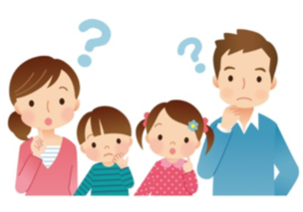

What is the purpose of catechesis?
According to the National Directory for Catechesis (NDC) there are 6 tasks of catechesis:
- Promotes knowledge of the faith.
- Promotes a knowledge of the meaning of the liturgy and the sacraments.
- Promotes moral formation in Jesus Christ.
- Teaches the Christian how to pray with Christ.
- Prepares the Christian to live in community and to participate actively in the life and mission of the Church.
- Promotes a missionary spirit that prepares the faithful to be present as Christians in society.
How long is faith formation?
Faith formation is lifelong. We should never to stop learning and growing in our relationship with Jesus and His Church.

At what age should my child begin formal Religious Education?
Children should be registered in our faith formation program when they begin 1st grade.
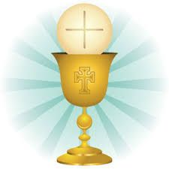
When does my child receive First Reconciliation and First Communion?
First Reconciliation is celebrated in February of a child’s second year of faith formation. First Holy Communion follows in the spring.
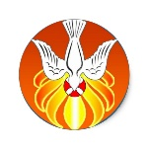
When is Confirmation celebrated?
Confirmation is generally celebrated in the spring of a child’s 8th grade year.

What should my child do for the years in between Communion and Confirmation?
Your child should register each year for faith formation classes (1st grade through 8th grade). This is extremely important in order for your child to grow in his/her relationship with the Lord and have the appropriate faith knowledge necessary before entering the immediate preparation for Confirmation which begins in Grade 7. (Please read about our different program options on the reverse side of page).
What happens if my child misses one or more years of faith formation?
If your child misses one or more years of religious instruction they will have to take a test in order to determine the most appropriate grade level placement. Your child will not automatically be put in the grade level he/she is in the public school.

Isn’t Confirmation a 2 year process?
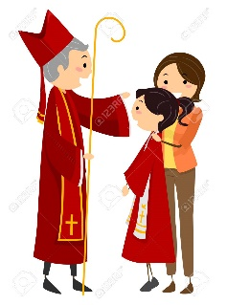
Confirmation is a two year process beginning in 7th grade with the Sacrament being conferred in the spring of 8th grade. However, if a child misses grades in between, he/she is unlikely to have sufficient knowledge/understanding of the faith necessary to begin Confirmation preparation.
A child must complete (at the minimum) the prior year before officially entering the preparation program. A child will be tested and placed in the appropriate grade level.
What if my child is in high school and has not received Confirmation?
If a child is in grades 9-11 and has not received the Sacrament of Confirmation he/she should register in our high school program. They will receive the Sacrament of Confirmation after completion of make-up work and two years of Confirmation preparation.
Do you have different program options to complete a grade level year?
Yes! We are aware of the different demands and challenges on families and try to offer a variety of program options to fit each family’s specific needs.
Traditional Program: Attend weekly classes for 1.5 hours. Classes begin at the end of September and end the first week of May.
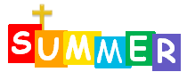
Summer Program: Two week intensive program which usually takes place in early July. Students attend daily for 9 days. Each day is 4 hours. Students will complete the program curriculum as well as have the opportunity to participate in daily Mass and adoration. Crafts and snacks are included each day. We do not offer the summer program for Sacrament years (Grades 2 & 8)
Home School Program: Parents are the primary educators of their child’s faith. Therefore you may choose to homeschool your child. You would take on the role of catechist. Your child will be provided with the same textbook as used in the class. You would schedule time each week to work on the lessons with your child. Reviews would be submitted to the Director of Religious Education and two yearly evaluation meetings for parents and children will be scheduled.
What does my child learn each year in Religious Education?
Our program uses the Loyola Press Finding God curriculum for grades 1-7. This is a spiraling series. The core concepts for each year are:
- Grade 1: God Found Everything Good-God & Creator
- Grade 2: I Am the True Vine-Eucharist & Reconciliation
- Grade 3: Fishers of Men-Church & Holy Spirit
- Grade 4: Blessed Are the Poor-Beatitudes & The Ten Commandments
- Grade 5: The Bread of Life-Sacraments & Worship
- Grade 6: I Am Who I Am-The Old Testament
- Grade 7: This is my Beloved Son-Jesus Christ
- Grade 8: Chosen “Your Journey Towards Confirmation” (Ascension Press)
“Train up a child in the way he should go; even when he is old he will not depart from it.” (Proverbs 22:6)

